Ravan Muradzada
Contents
Apache Tasks 1
Task 1 1
Task 2 3
Task 3 4
Task 4 6
Task 5 7
Firewalld 9
Task 1 9
Task 2 10
Task 3 11
Task 4 11
Task 5 12

Apache Tasks

Task 1
First, we need to go to the directory and create virtual host inside:
Its content:
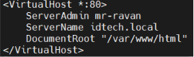
As you can see, its data (like html files) located in the same directory with the default one.
Then we need to add apache port to firewall. First, let’s check firewall status:
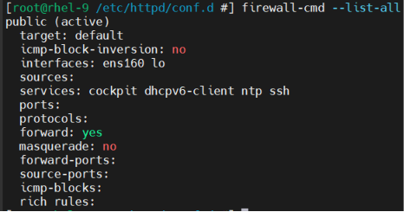
As you can see, apache port (80) has not added yet. Let’s add it:
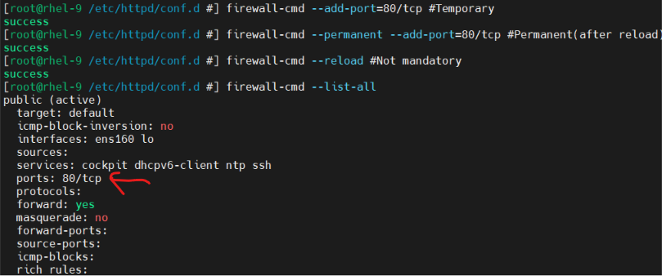
Then we restart the apache service:
Now let’s redirect the html content to the index.html in default location:
Let’s check it from browser by typing “192.168.88.160:80”. (the first part is my ip and the second part is port of apache):
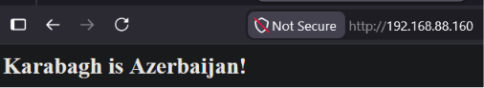
We can also use `curl` to check: 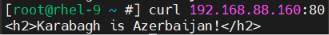

Task 2
We go to `/etc/httpd/conf.d/` directory to create and config virtual host. Let’s create a file:
Contents: 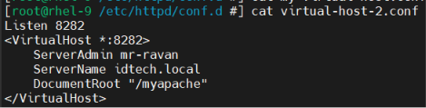
We create a directory and index.html:
Let’s add the port to firewall:
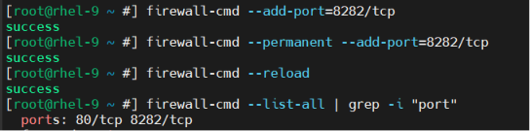
Let’s add the port to SELinux:
Let’s add the new directory to SELinux:
It is good to add (not mandatory) this to `/etc/httpd/conf/httpd.conf` file:
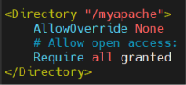
Then we need to restart httpd service:
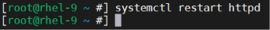
We type this in the browser: `192.168.88.160:8282`.

We can also use `curl`: 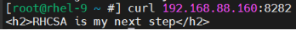

Task 3
Let’s download the package:
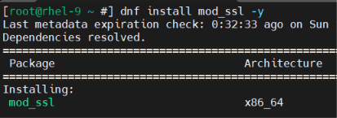
Remove the config file:
Let’s generate certificates:
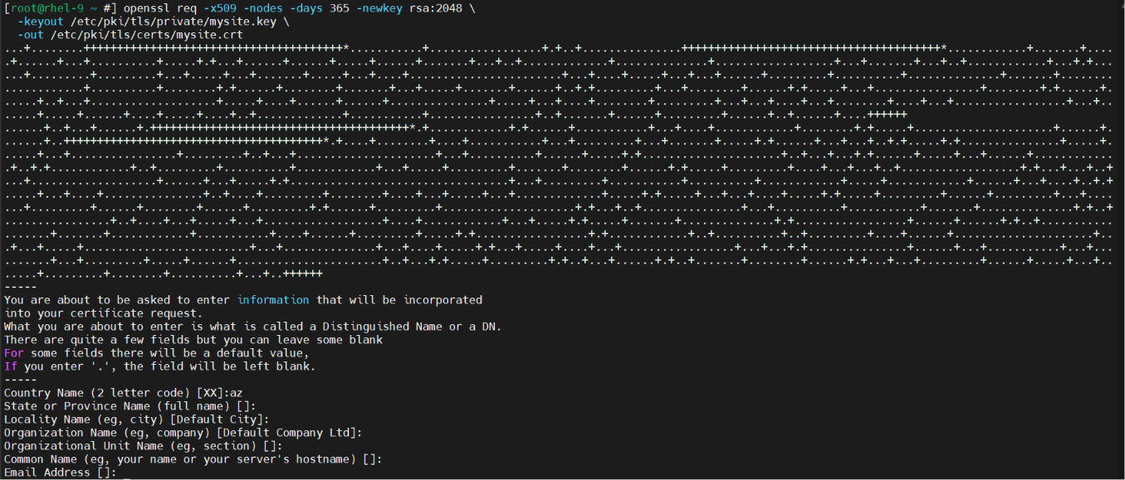

Let’s create virtual host:
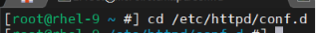
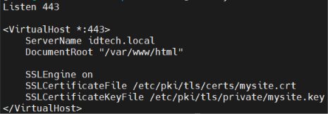
Now add the port to firewall:
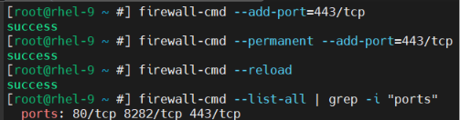
Now restart the apache:
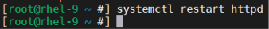
Now we can check it in browser. We need to write just `https://192.168.88.160`. Here browser shows the certificate warning, if we proceed it:
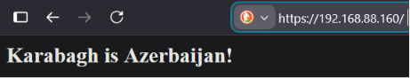
Moreover, we can also use `curl`:
Here -k flag skips certificate verification because it's self-signed.

Task 4
We need to open the virtual host file and add one line there:
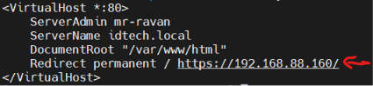
Then we need to restart apache:
Checking:
If we try to write `http://192.168.88.160:80/` in the browser:
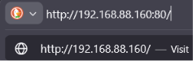
(It will be redirected to https):
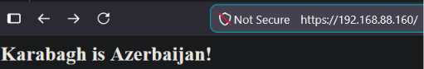

Task 5
Let’s create the directory and index.html:
Let’s create the password file(I gave password as `123`):
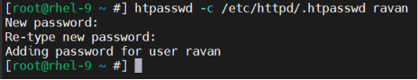
`-c` is used to create the file. If file already exists, we do not use this flag.
Let’s open virtual host which we have created in task 3 and add the directory block to it.
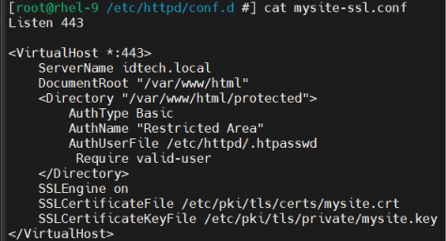
Then we should restart the service:
Let’s check the result with `curl`:
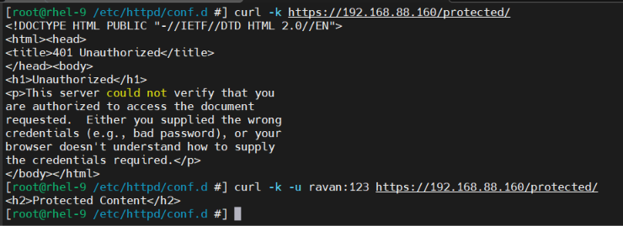
In the first one there is no auth, so it does not give a result. The second one I have added auth credentials, so it gives the proper result.
If we can look at from browser, too:
When we type it:
 and press Enter, this will come:
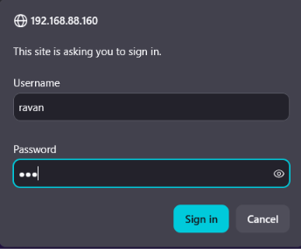
When I enter everything correctly and click sign in, this will come: 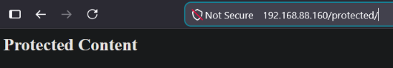

Firewalld

Task 1
BTW, I have created `fcmd` as alias of `firewall-cmd`.
To create a new zone:
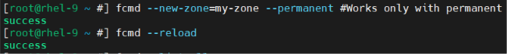
We run this command to find our zone:
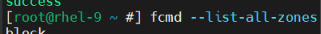
This is ours:
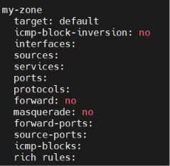

Task 2
I didn’t understand what kind of ‘service’ you meant. If you meant systemd service, I have shown it below (in this task). However, if you mean firewall service, I have already handled it in Task 5 of Firewalld.
First, I create a script file inside `/usr/bin/` directory:
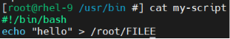
Let’s create a service file in `/etc/system/system/` where this script above is called:
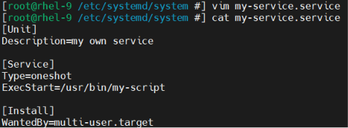
Let’s enable and start the service:
We can check it:

Task 3
First, let’s add this port to firewall:
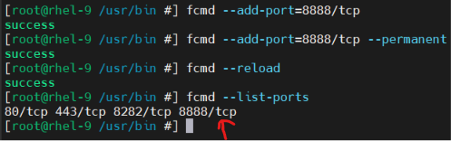
Let’s start listening from linux:
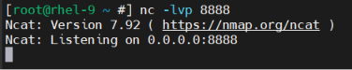
Here `-l` means listen, `-v` means verbose and `-p` means port.
Let’s go to cmd in windows and type this:
Afterward we can see it in linux:
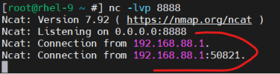

Task 4
If you mean to allow mysql service in firewall, let’s download it:
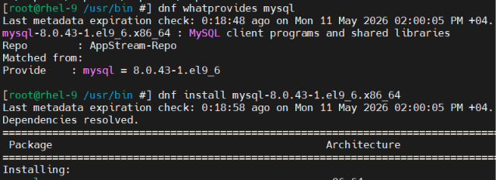
Let’s add it to firewall:
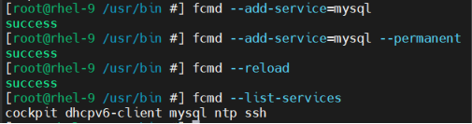
(Installing the service (mysql) is not required. I did it just for fun)

Task 5
Adding it as a port is easy, we just need to run `firewall-cmd –add-port=8282/tcp –permanent` and `firewall-cmd –add-port=8282/tcp`. Now let’s do it as a service file (firewall service).
Let’s do it in a service file under firewall.
I have created a service file named `my-service.xml`:
Inside the file:
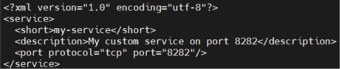
Then we should reload it:
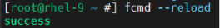
Let’s check it:
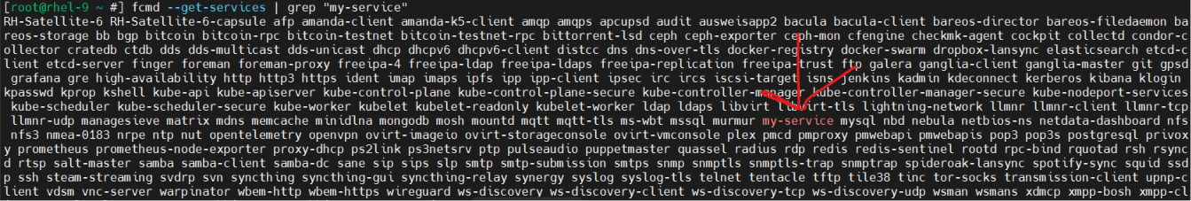
Now let’s add it to firewall:
